General – Early warning
Original | New
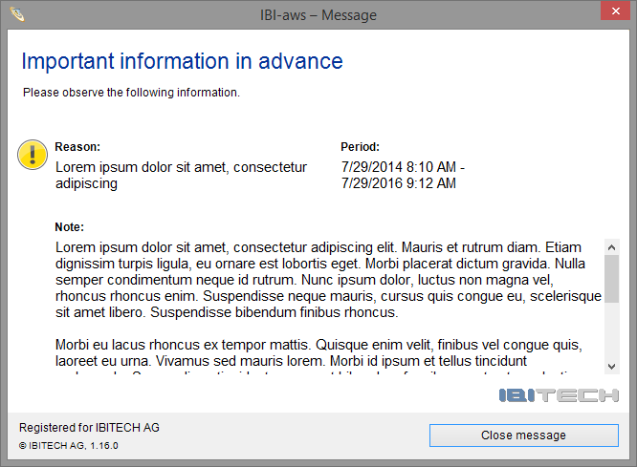
Fullscreen
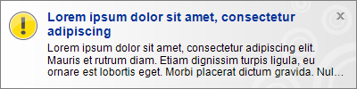
Insertion

General
Original | New
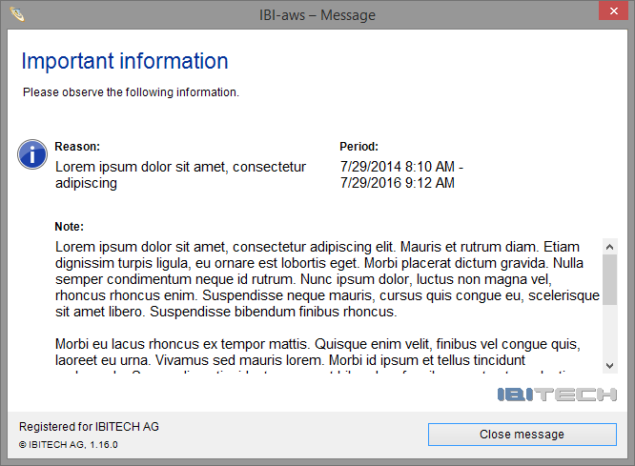
Fullscreen
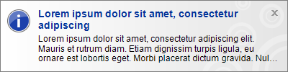
Insertion

General – Status update
Original | New
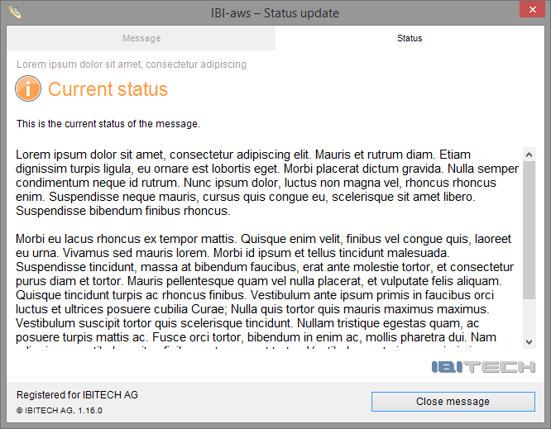
Fullscreen
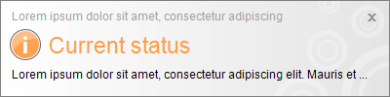
Insertion

General – Resolve message
Original | New
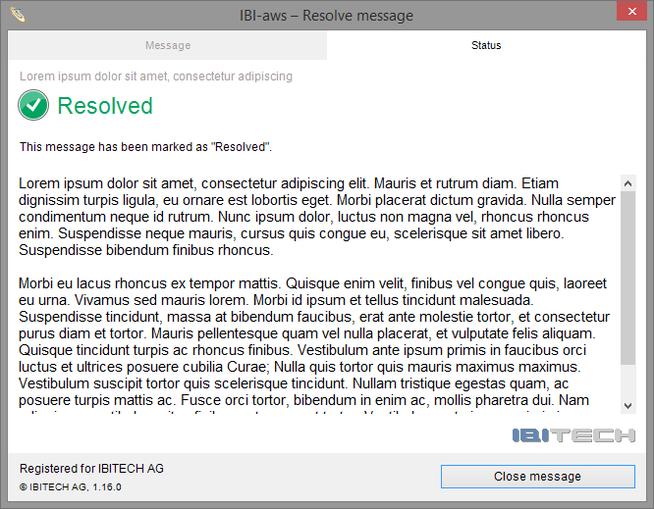
Fullscreen

Insertion

Applicationspecific – Early warning
Original | New
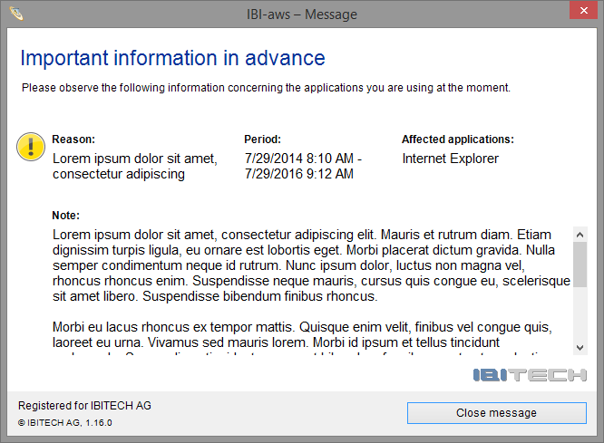
Fullscreen
Insertion

Applicationspecific
Original | New
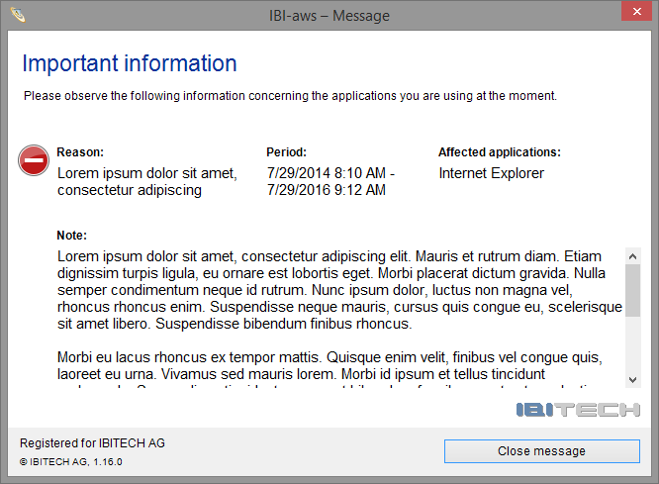
Fullscreen
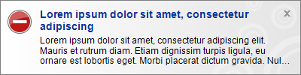
Insertion

Applicationspecific – Status update
Original | New
Fullscreen
Insertion

Applicationspecific – Resolve message
Original | New
Fullscreen
Insertion

Static
Original | New
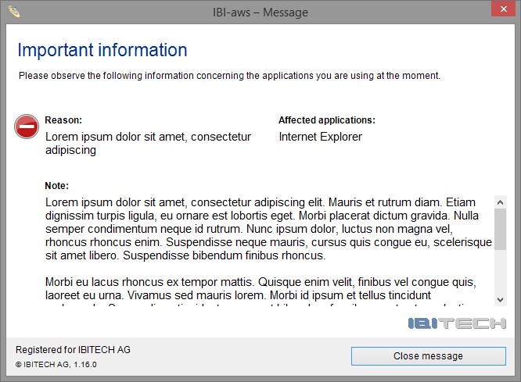
Fullscreen

Tray icon
Original | New

Default


Active messages


Silent message (flashing)

